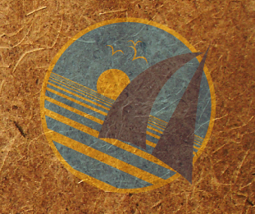
OceanGybe Beach Pollution Study

Location: Aneityum Island, Vanuatu
Latitude: 20° 14’ S
Longitude: 169° 50’ S

Local Geography: Aneityum is the southern-most island in the Vanuatu chain. It is heavily wooded with characteristic volcanic features. The study bay is located on the south western edge of the island. The bay is almost completely circled in the outlying reefs, with a deep sand-bottom lagoon between the mainland and the reefs. Numerous rivers empty into the bay, and were active given our arrival at the end of the wet season.

Local Population Size: The local village would have a permanent population of approximately 100 people. There are several other villages in the neightbouring bays and in the mountains. There is one little “store” on the island but all the islanders live in a subsisence manner, farming the hills and catching fish from the ocean to survive. As a result very little non-biological garbage is produced.

Study Location Description: The study was completed inside the lagoon on the eastern shore. There is a break in the reef, just upwind of the study location which will allow oceanborne garbage to float though. There are no neightbouring islands to the windward of the lagoon, therefore all garbage floating through the pass is blue water, deep ocean garbage.

Study Area: The study area covered approximately 90m X 3m, and spread from the high-tide line up to the beginning of the jungle. We had two local children help us collect and count the refuse.

Pollution:
- 22 plastic bottle lids
- 14 plastic wrappers
- 8 plastic bottles
- 6 sandals
- 67 random pieces of plastic
- 4 plastic bottles
- 3 pieces of random fishing equipment

Pollution Density: 124 pieces of garbage in 270 m² = 0.46 pieces of garbage / m²

Recycling Programs Locally: All glass bottles and containers are extremely useful on the island for storing oil and other liquids in. These are recycled in the true sense of the word, they are cleaned and reused and reused…

Notes: Despite the local population, I would regard most of this garbage found as oceanborne due to their complete non-use of plastic and consumer goods. The Ni-Vanuatu farm their own food, the catch their own fish and pigs, and live a few non-consumerist lifestyle. 95 % of their waste if natural and biodegrable.

