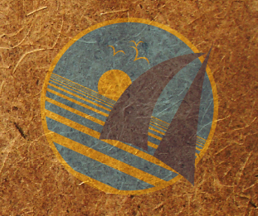
OceanGybe Beach Pollution Study

Location: Hollandes Cays, San Blas Islands, Panama
Latitude: 9º 35.1’ N
Longitude: 078º 46.4’ W

Local Geography: San Blas Islands are a archipelago of low-lying sand and coral islands between 2 and 30nm offshore from Mainland Panama. Generally surrounded by outer reefs and populated sparsely by the Kuna Indians. Most islands would be less than 5m above sea level.

Local Population Size: Immediate location – zero. Neighboring island has a single family of approximately 10 persons. Many cruising sailboats are anchored just windward of the islands and could be a source of pollution.

Study Location Description: Shallow sloping coral and sand beach with embankment at the high tide line. High tide line and seaward expansion of palm trees form a 1-2ft embankment. Sandy shrub ground cover on land, while a barrier reef extended up to 1nm offshore.

Study Area: 100m X 3m = 300m²

Litter: Drinking Bottles: 234
Pieces of foam: 243
Glass bottles: 6
Sandles/Shoes: 23
Light bulbs: 8
Lighters: 2
Small Plastic Containers: 34

Pollution Density: 550 pieces / 300m² = 1.83 pieces/m²

Garbage / Recycling Programs Locally: None.

