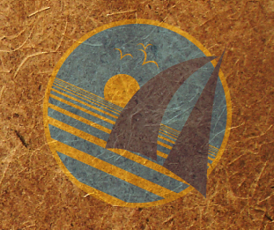
OceanGybe Beach Pollution Study

Location: Parida Island, Panama
Latitude: 8º 05’ N
Longitude: 082 º 21.5’ W

Local Geography: Parida Island is an island offshore from the Chiquiri Gulf on the Pacific coast of Panama. Located offshore from Boca Grande and the rivers which drain past David, one of the larger cities in Panama.

Local Population Size: Immediate location – 10. Very little local occupation most visitors would have come via boat.

Study Location Description: Small enclosed bay of Ensanada Grande on the western side of the island. Steep cliffs on both sides of the bay and a small river discharging in the southern corner. Shallow sloping beach, with significant depth increases just beyond area of wave action. Sandy foreshore populated only by palm trees.

Study Area: 100m X 2m = 200m²

Pollution: Large plastic containers: 4
Pop/Water bottles: 0
Bottle caps: 28
Deodorant sticks: 3
Large random plastic pieces: 14
Small plastic containers: 3
Toy pieces: 1
Oil Container: 1
Plastic rope: 8
Drinking cups: 2
Styrofoam: 1
Flip-flop: 1
Small Random pieces: 60

Interesting items: Transformer (toy) arm, bucket, fishing net, men’s comb, spray can widget (2x), Lego, toothbrush, syringe.

Total Garbage Weight: 1.5 kg

Pollution Density: 134 pieces / 200m² = 0.67 pieces/m²

Recycling Programs Locally: None

Notes: Lack of pop/water bottles is interesting as we have found at least one of these at every location thus far. The high percentage of fishing rope and nets indicates that fishermen may use the bay as a stopping point or location to hide from heavy weather. Much of the refuse was covered with barnacles and heavily weathered indication long residence tide in the ocean and assumed to be deposited in significantly distance locations.

