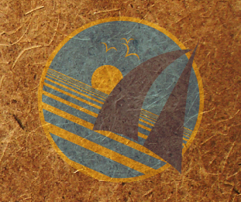
OceanGybe Beach Pollution Study

Location: Rarotonga Island, Cook Islands
Latitude: 21°15’ S
Longitude: 159°50’ W

Local Geography: Rarotonga is the youngest island in the Cook Island chain. As a result it has the most dramatic topography, rising from sea level to 700m above sea level. Fringing reef surrounds most of the island, with small lagoons begin to feature on the southern side as the island ages.

Local Population Size: The island is huge tourist hub for many visitors to the South Pacific. As a New Zealand dependency, it is relatively cheap to visit and explore. The Population is approx. 18 000 but fluctuates greatly depending on the time of year.

Study Location Description: The beach study was completed on the north-east facing coast. This coastline faces directly into the trade winds at the time of year which the study was completed. It was a straight piece of coastline with no discernable points, bays or other geographical features. It was in front of an elementary school and may have been cleaned sometime in the recent history.

Study Area: A randomly chosen piece of beach along a straight stretch of approximately 400 m. Study was completed over a 200m X 4m (800m² Area) rectangle.

Pollution:
- 10 pop bottles lids
- 2 large pop bottles
- 4 large plastic pieces
- 5 random socks and such
- 11 pieces of random plastic

Pollution Density: 0.04 pieces/m²

Recycling Programs Locally: Local recycling of glass bottles and numerous garbage bins on the beach helped keep garbage levels low. The school was also conducting a aluminium can recycling program. Children were encouraged to bring cans to school in order to win their class a prize. This could easily have contributed to the “clean” nature of the beach.

