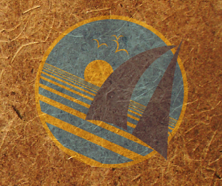
OceanGybe Beach Pollution Study

Location: Fakarawa Atoll, Tuamotu Islands
Latitude: 16°07’ S
Longitude: 145°35’ W

Local Geography: Fakarawa is the second largest atoll in the Tuamotu Island chain. Measuring almost 60km by 25km, the atoll is quickly becoming hugely renowned for it’s amazing scuba diving and prolific ocean life. The island hardly lies more the 20m above sea level at any point. It is completely surrounded by coral reefs and only has two boat passes into the lagoon.

Local Population Size: The atoll has two “villages”, Rotoava and Tetamanu. Tetamanu is a diving resort on the southern end of the island and has approximately 10 permanent residents. Rotoava, on the northern end, is a decent size village and approximately 500 people live there on a permanent basis.

Study Location Description: The beach study was completed on the north-east facing coast. This coastline faces directly into the trade winds at the time of year which the study was completed. It was a straight piece of coastline with no discernable points, bays or other geographical features. Local currents sweep south west down the coast.

Study Area: A randomly chosen piece of beach along a straight stretch of approximately 2 km. Study was completed over a 100m X 4m (400m² Area) rectangle.

Pollution:
-15 pop bottles
- 45 large plastic pieces
- 3 large chunks styrofoam
- 3 glass bottles
- 4 rubber fishing floats
- 30 pieces of line
- 1 piece random rubber
- 84 pop bottle caps
- 10 random plastic caps

Pollution Density: 0.49 pieces/m²

Recycling Programs Locally: Local recycling of glass bottles and numerous garbage bins on the beach helped keep garbage levels low.

Notes: The biggest amount of plastic garbage on this beach was not the large pieces which littered the beach but rather the tiny little pieces. The beach was literally a technicolour nightmare. Instead of white, brown and black sand and coral pieces, the sand was filled with yellow, red, blue and green pieces of plastic. The high density of tiny piece could be due to the high wave action just offshore breaking bigger pieces of plastic into smaller and smaller particles.

