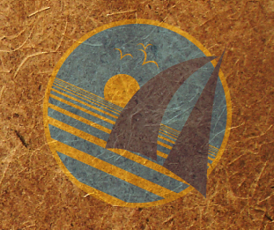
OceanGybe Beach Pollution Study

Location: Savu Island, Indonesia
Latitude: 10° 27.4’ S
Longitude: 121° 50.8’ S

Local Geography: Savu is a dry and barren island located in the south east of Indonesia and is part of the Nusa Tenggara Province. The island is flat with very no major peaks of topographical features. The coastline is generally coral reef, interspersed with patches of brilliant white sand.

Local Population Size: There is one major town on the island, Sabu, and the entire island has a population of approximately 60 000. This figure is taken from the Lonely Planet guidebook and seems vastly exaggerated in contrast to the amount of people encountered during our weeklong stay.

Study Location Description: The study was completed on a north-west facing beach in the lee of the island. Very little wind was present and it can be assumed that most of the garbage entered the ocean locally, or would have been carried the opposite direction by the trade winds.

Study Area: The study area covered a 50m X 3m block along the high tide line. The beach featured a steep beach slope and two reefs marked the entrance to the bay. No other major distinguishable features existed.

Pollution:
- 92 pieces of assorted plastic.
- 3 pieces of fishing nets
- 23 bottle caps
- 20 pieces of styrofoam
- 9 rubber sandals
- 32 small pieces of rope
- 1 plastic bucket
- 1 plastic belt
- 1 sambal bottle

Pollution Density: 1.22 pieces of garbage / m²

Recycling Programs Locally: None.

Notes: Interesting to note the complete lack of water containers. This is despite the fact that the local water is not consumable and huge water containers are constantly begin shipped to the island to accommodate the local needs.

